CTAI Team Project: Functional Analysis

NILM – Non-Intrusive Load Monitoring
Team Project CTAI – Energy
Client: Jeroen De Baets – Energy Lab (Smappee)
January 2026

- Introduction and context

The energy sector is undergoing a significant transformation. Households and small businesses are increasingly adopting technologies such as electric vehicles, heat pumps, and home battery systems. This shift towards electrification creates a growing need to understand and manage energy consumption patterns more precisely.

The client for this project, Jeroen De Baets, provides access to measurement data from a building. The dataset includes both the total energy consumption of the building over time and individual appliance measurements. While aggregate consumption is useful, it does not directly show how much each appliance contributes to the total usage or which devices are responsible for peaks in demand.

This project investigates whether artificial intelligence can be used to determine which appliances are active and how much power each one consumes using only the aggregate power measurement, even though individual appliance data is available for validation and benchmarking.

- Problem Definition

Energy consumers currently lack visibility into their appliance-level consumption. A typical electricity bill only shows the total energy used over a period, without indicating how much is due to specific devices such as heat pumps, electric vehicle chargers, or other major loads.

This lack of granularity makes it difficult for consumers to understand where their energy is going and to adjust their behaviour accordingly. Similarly, an energy advisor visiting a home cannot quickly identify inefficient appliances or abnormal consumption patterns without installing additional monitoring equipment on individual devices.

Project goal: Develop a proof of concept that can automatically recognize which appliances are active based on a building’s total energy measurement and estimate how much power each appliance is consuming at any given moment.

- Proposed Solution

The proposed solution is based on Non-Intrusive Load Monitoring (NILM).
In this approach, machine learning algorithms analyse the aggregate power signal from a single meter and decompose it into estimated contributions from individual appliances.

The key idea behind NILM is that each appliance exhibits a characteristic electrical signature. For example, a dishwasher follows a predictable cycle with distinct power levels during washing, rinsing, and drying phases.
A heat pump operates in patterns linked to temperature regulation, while an electric vehicle charger typically draws a relatively constant high power during charging sessions.
By learning these patterns from data, the system can infer which appliances are active and estimate their power consumption from the total measured load.

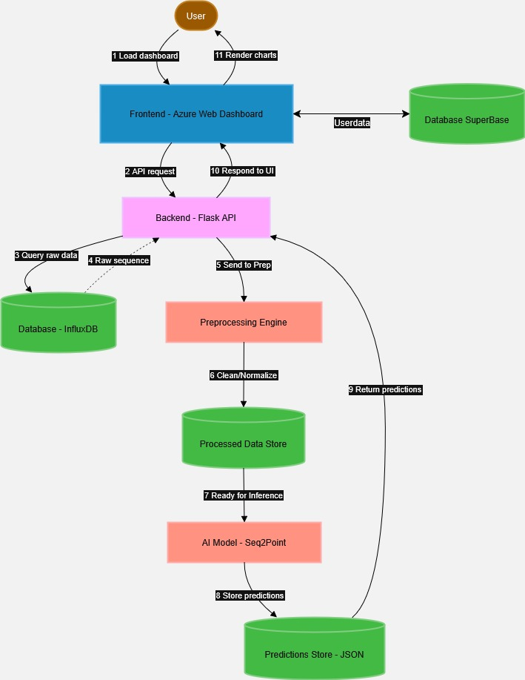

The system architecture connects the user dashboard to the NILM model through a backend and data pipeline. When the user loads the web dashboard, the frontend sends an API request to the Flask backend, which queries raw aggregate data from InfluxDB. The preprocessing engine cleans, normalizes, and stores this data in a processed data store, from which the Transformer-based seq2point NILM model performs inference. The model’s predictions are saved in a JSON prediction store and returned by the backend to the frontend. Finally, the dashboard renders charts and visualizations that show total and per-appliance consumption to the user.

- Target Audience
Residential energy consumers are the primary beneficiaries of this technology.
They want to understand which appliances consume the most energy and identify opportunities to reduce their consumption. Many of them have recently installed technologies such as solar panels or heat pumps and would like to see how these investments affect their overall energy patterns.

Energy advisors and consultants visit homes and businesses to provide recommendations for improving energy efficiency. Access to appliance-level consumption data enables them to make more specific and actionable suggestions, for example by identifying devices that consume significantly more energy than expected or contribute disproportionately to peak loads.
For the client, Jeroen De Baets, the project provides a way to extract more value from existing measurement data by turning raw time-series into interpretable appliance-level insights that can support both end users and professional advisors.

- Comparison with Existing Solutions

Traditional solutions install dedicated sensors on each device.
This is accurate but requires significant hardware, installation effort, and cost.

Smart plugs are simpler but only work for plug-in devices. Large consumers such as heat pumps, EV chargers, and built-in appliances are hardwired and cannot be covered this way.
Commercial NILM products (e.g. Sense, Voltaware) offer disaggregation but usually require extra hardware and sometimes subscriptions, with accuracy that depends strongly on the appliance mix and setup.

In contrast, this project uses measurement data that is already available from the building, without additional hardware. The models are trained on data from the specific site and provide documented performance metrics per appliance, so stakeholders clearly see how well the system works.

- Core MVP Features

The current implementation includes a complete data processing pipeline that ingests raw measurement data from InfluxDB and prepares it for model training. The preprocessing system handles data at multiple time resolutions, including measurements taken every fifteen minutes and high-frequency data captured every second.

Detected Appliances
The system currently supports detection of eleven different appliances and energy sources:
HVAC: Heat Pump, Heat Pump Controller
Kitchen: Dishwasher, Oven, Stove, Range Hood
Laundry: Washing Machine, Dryer
EV Charging: EV Charger, EV Socket, Smappee Charger
Other: Garage Cabinet, Rainwater Pump, Solar, Grid, Battery

Throughout development, we implemented and evaluated nine different architectures, benchmarking traditional LSTM models against more recent deep learning approaches. A Transformer-based seq2point architecture emerged as the best overall solution, combining the seq2point learning setup with a Transformer backbone to better capture long-range dependencies while remaining scalable.

At the same time, the evaluation shows that there is still room for improvement in absolute accuracy. Class imbalance between active and inactive appliance states and the complexity of real load signatures remain challenging. A weighted NILM loss function helped reduce the impact of rare activation events, but the final performance is still sensitive to model hyperparameters and post-processing choices, which defines a clear direction for future optimisation.

- User Flow
The data journey begins at the building’s electrical panel, where a monitoring device continuously measures the aggregate power consumption and stores the values in an InfluxDB time-series database.

Measurement data is exported from InfluxDB in CSV format at the desired time resolution. The preprocessing stage cleans the raw data by handling missing values, correcting sensor offsets, and normalizing the measurements.
The cleaned data is then segmented into overlapping windows that serve as training examples.
During training, the model learns to associate patterns in the aggregate signal with the consumption of specific appliances.
At inference time, the trained model receives recent aggregate measurements and produces an estimate of the current power consumption for each appliance.

- Wireframe Description

The planned dashboard interface consists of several interconnected views that guide the user from onboarding to detailed appliance insights. The wireframes are illustrative; the final visual design may evolve, but the core structure and information architecture will remain similar.
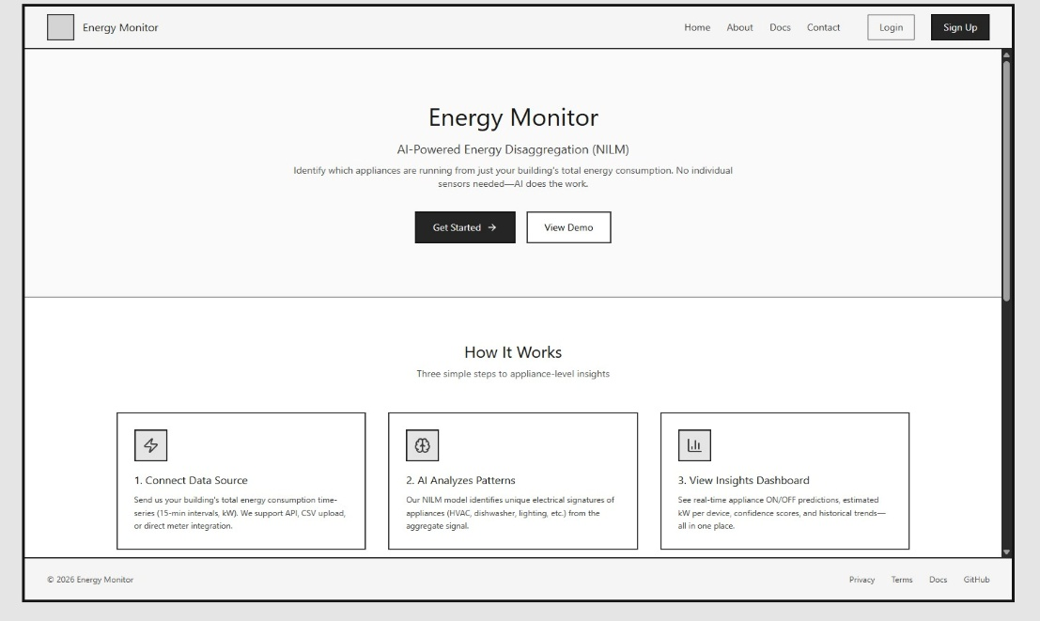
Figure 1 - Landing page wireframe

Figure 1 shows the public landing page for the Energy Monitor application. It introduces the concept of AI-powered energy disaggregation in clear, non-technical language and explains the three main steps: connect a building’s data source, let the AI model analyse patterns, and view appliance-level insights in the dashboard. Prominent “Get Started” and “View Demo” buttons lead users either to onboarding or to a guided demonstration. This page is designed to set expectations and build trust before login.

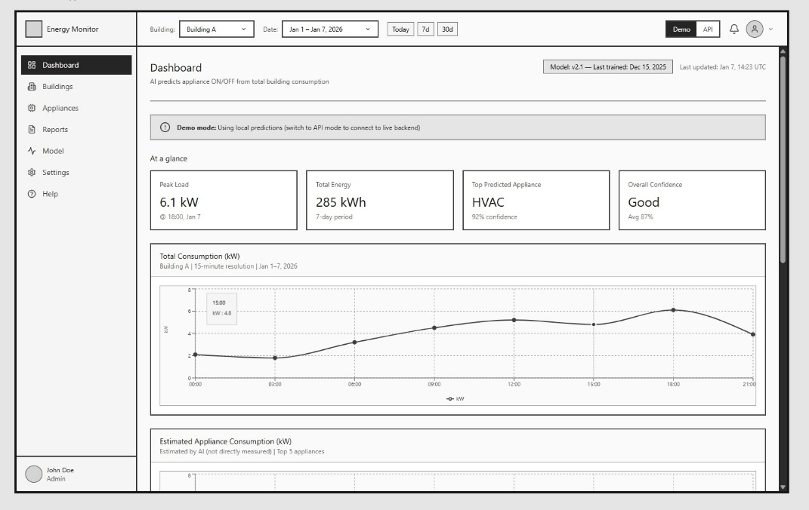
Figure 2 - Main Dashboard

Figure 2 presents the main dashboard that users see after logging in and selecting a building and date range. Summary cards highlight peak load, total energy, and the top predicted appliance. Time-series charts display total consumption and estimated appliance-level consumption, allowing users to quickly see which devices contribute most to their usage over time.

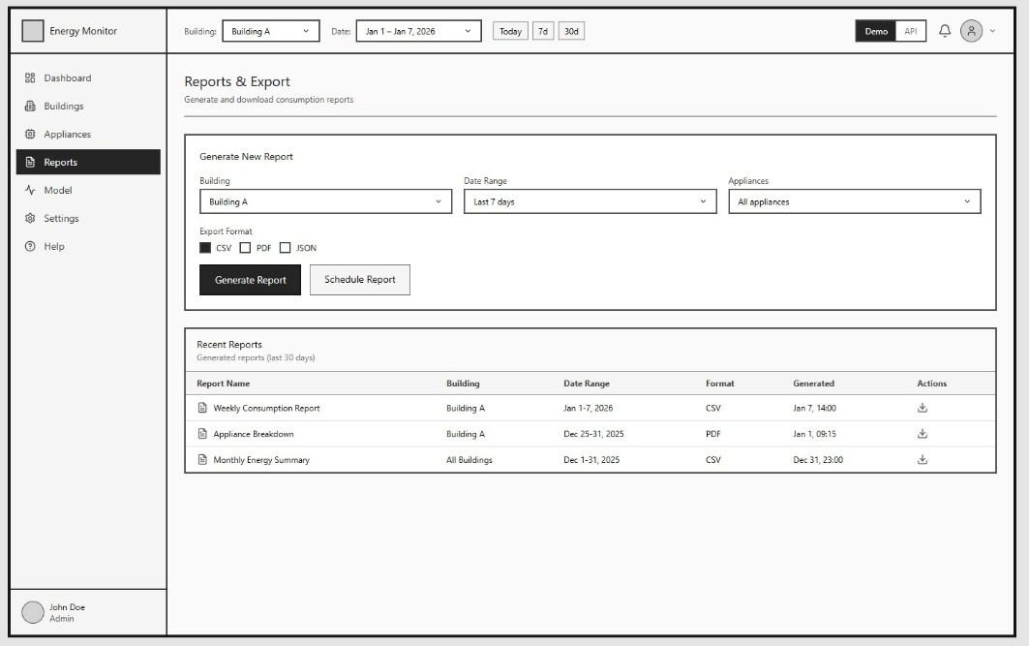
Figure 3 - Reports and Exports

Figure 3 shows the reports view. Users can generate appliance or consumption reports by choosing a building, date range, and export format (CSV, PDF, JSON). A list of recent reports with download actions supports sharing results and performing offline analysis.
Across these wireframes, the design focuses on a clean layout and simple charts so that complex energy and model information remains understandable for non-technical users.

Additional Interface Features
The application also provides views for managing buildings and monitoring the NILM model.
A building overview page shows the status of a selected site, including connection state, last data timestamp, number of recent data points, and identified appliances. It also displays key building details and a 30-day data-coverage calendar.
A buildings management view lists all sites in a table with name, ID, location, last data timestamp, and status, plus a simple form to add new buildings.
A model status view shows the current model version, training status, overall accuracy, and core metrics, along with basic controls for selecting a training data range and triggering retraining. And more will be implemented soon.

- Data Pipeline and Quality

Available datasets
- 15min – Resolution: 15 minutes; Period: Oct 2024 – Oct 2025; Records: 35,040; Status: Primary, complete.

- 1sec (old) – Resolution: 1–10 seconds; Period: Mar – Dec 2024; Records: ~15 million; Status: Limited, about 70 usable days.

- 1sec_new – Resolution: 1 second; Period: Mar 2024 – Dec 2025; Records: ~55 million; Status: Newly received on 14 January 2026.

Dataset details
- 15-minute dataset (primary):
One full year of data covering twelve appliances. Preprocessing is complete: negative values have been clipped, double-counting corrected, and gaps interpolated. The final energy balance error is approximately 0.33%, making this the reference dataset for model training and evaluation.

- 1-second original dataset (limited):
The building aggregate sensor stopped recording on 4 June 2024, so only March–May (around 70 days) are usable. Several appliances are missing (garage cabinet, charging socket, heat pump controller), and the EV charger column is entirely null. This limits its value for robust model training.

- 1-second new dataset (recently acquired):
A significantly improved high-frequency dataset provided by the client on 14 January 2026. It includes grid and solar measurements that were absent from the original 1-second data. Some preprocessing is still required (handling negative values and a variable schema), but overall coverage and quality are much better, making it a strong candidate for future high-resolution NILM experiments.

All the models and architectures described above were trained using only the 15-minute dataset, which served as the primary and most stable data source during development.
With the newly acquired 1-second dataset, future work will focus on extending and retraining the best-performing architectures on high-resolution data. This is expected to improve the detection of short-lived events, capture more detailed appliance signatures, and ultimately increase both the accuracy and robustness of the NILM predictions.

- Results from Testing

Model performance (15-minute resolution)
All models reported below were trained and evaluated on the 15-minute dataset.
- Dishwasher – MAE 28.5 W – ✅ Excellent
The model clearly captures the distinct wash, rinse, and dry phases, with accurate power levels across the full cycle.
- Washing Machine – MAE 37.4 W – ✅ Very good
Main wash phases are reliably detected, with only minor deviations during short transitional states.
- Charging Station – MAE 104.5 W – ⚠️ Good
Charging sessions are identified correctly, but variable power levels within a session lead to higher error.
- Heat Pump – MAE 125.3 W – ⚠️ Fair
The model detects general operation but sometimes confuses the heat pump with the garage cabinet due to similar power profiles and overlapping schedules.
(see images below)
- Smappee Charger – MAE 155.7 W – ❌ Needs improvement
Events are often missed or underestimated, indicating the need for better feature engineering or higher-resolution data.

MAE (Mean Absolute Error) represents the average prediction error in watts; lower values indicate better performance.
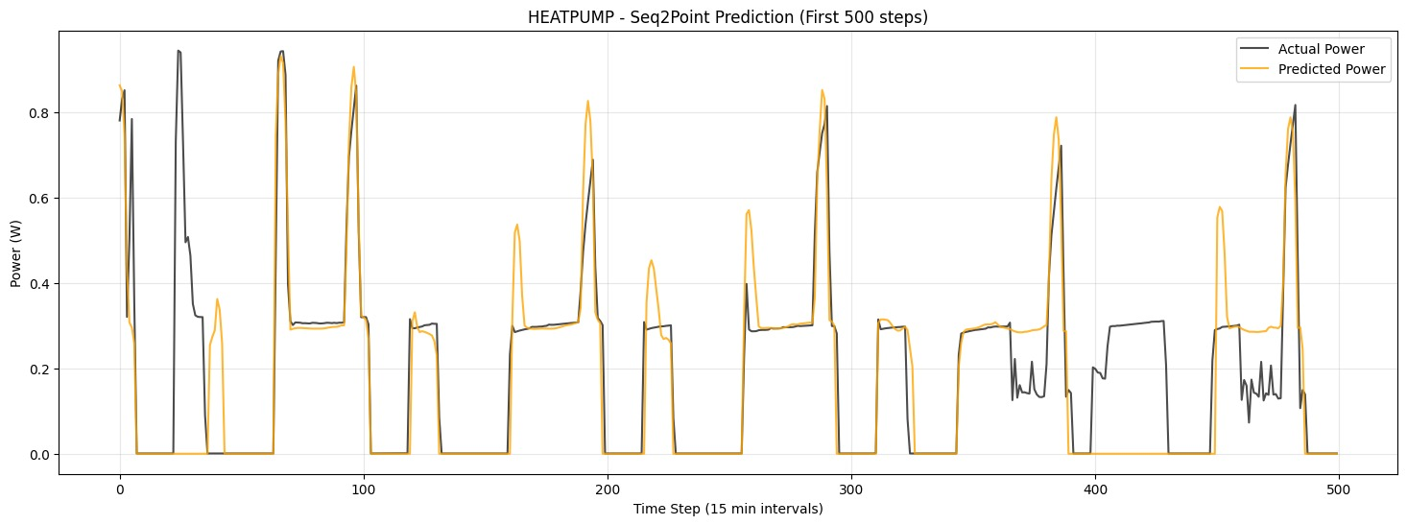

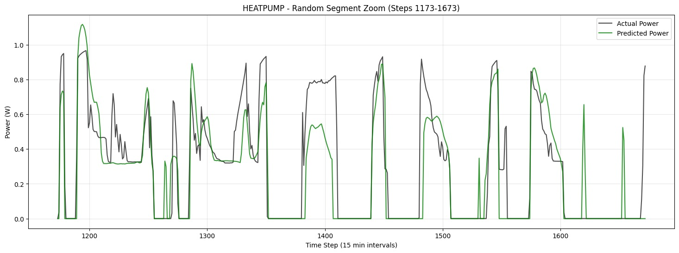

Resolution limitations
The 15-minute sampling interval imposes hard limits on which appliances can be detected:
- Longer-duration appliances such as heat pumps (30–60 minutes per cycle), dishwashers (60–120 minutes), and EV charging (1–4 hours) span multiple time steps and are therefore well suited to this resolution.
- Short-duration appliances such as microwaves, kettles, and some cooking events often complete their operation within a single 15-minute window. Their energy is averaged together with other loads and effectively disappears in the aggregate signal.
As a result, very short events are fundamentally undetectable at 15-minute resolution. This limitation is due to the data granularity itself, not a deficiency of the NILM model.

Key findings
- The dishwasher and washing machine models achieve high accuracy and can be considered production-ready at this resolution.
- The heat pump and charging station models provide useful signals but still suffer from confusion with similar loads and variable power levels.
- The Smappee charger remains a challenging device at 15-minute resolution, highlighting the need for additional data and model refinement, or for leveraging the new 1-second dataset in future work.

- Conclusions and Recommendations

This functional analysis shows that Non-Intrusive Load Monitoring is a viable approach for providing appliance-level consumption insights using only aggregate building measurements. The proof of concept successfully detects and estimates power consumption for several key appliances, demonstrating that meaningful disaggregation is possible without installing additional per-device sensors.
The system is particularly effective for appliances with distinctive and longer usage patterns, such as dishwashers and washing machines, where the 15-minute resolution is sufficient to capture complete cycles. Other devices with more complex or shorter-lived signatures remain challenging and require further refinement and, where possible, higher-resolution data.

Next steps
- Complete preprocessing for new dataset: Clean the recently acquired 1-second data (handle negative values, variable schema, fill missing columns)
- Train and evaluate Transformer model on high-resolution data: Apply the best-performing architecture to the new 21-month dataset for improved accuracy
- Evaluate short-cycle appliance detection: Test if 1-second resolution enables detection of appliances previously impossible to identify (microwave, kettle, cooking events)
- Implement backend API: Create the inference architecture with endpoints for real-time appliance predictions, as in the image shown above.
- Improve user dashboard: Improve the frontend interface to visualize consumption breakdown and historical patterns with the real data.

Trello Link:
https://trello.com/b/bm1Qd3Wa/energyg1

Github Link:
https://github.com/Thetommigun432/MTS3-MCTE-Team-Project-Energy-G1

